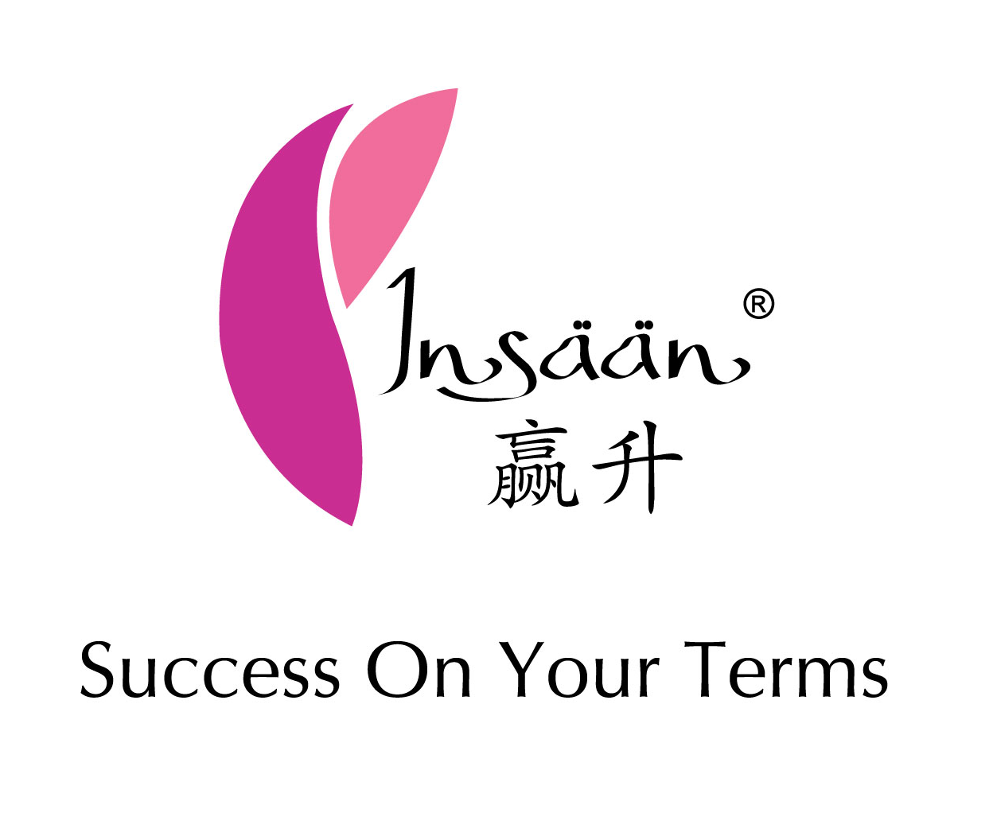
成功之道
Road to Success (RTS)
Date: ______________________
Time: 9.15am – 5.30pm
Venue: _____________________
Language: Chinese
-------------------------------- 报名表格Registration Form ---------------------------------
传销商名字(英) 传销商加入配套(请选择－画圈圈)
Distributor Name: ________________________ Join Package: Titanium / Platinum / Gold / Classic

身份证号码 联络号码
NRIC Number: ____________________________ Contact Number: ________________________

传销商编号 加入日期
Distributor ID: ___________________________ Join Date: ______________________________

上线名字 联络号码
Upline Full Name: _________________________ Contact Number: ________________________

报名费Registration Fees: $99.00 Payment Mode : CASH ([For Staff Use]Cash Bill No: ____________)
(包括included：礼品door gift，早点morning tea break，午餐lunch)

报名截止日期Registration Deadline: _______________________
(*任何报名表格迟交者將不被處理.Late submission will not be entertained your understanding is very much appreciated)

规则 Terms & Conditions
公開于所有Al-Insaan事業伙伴参加 Open to all Al-Insaan Business Partner
不準穿短褲及拖鞋 No Slipper & Short pant is allowed
費用不能退還或轉讓 Registration Fees are not refundable or transferrable
临时缺席者不能索取任何产品或转让 For those who absent will NOT entitled for any redemption or replacement.
准时报到及上课 Be punctual & fully attend the Seminar
公司有权在无通知的情况之下更改条规Al-Insaan Sdn Bhd reserves the right to change or amend the above terms and conditions to prior notice.

*我同意以上一切上课詳情與規則不会擅自离场I hereby accept the rules & regulations as per abovementioned and my acknowledgment on acceptance as below: -

簽名Signature: ______________________________ 日期Date: _________________

